Travel Group:

Special Sunset Cruise – Sunday 11th June

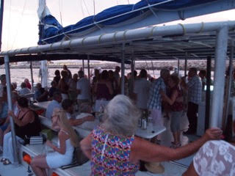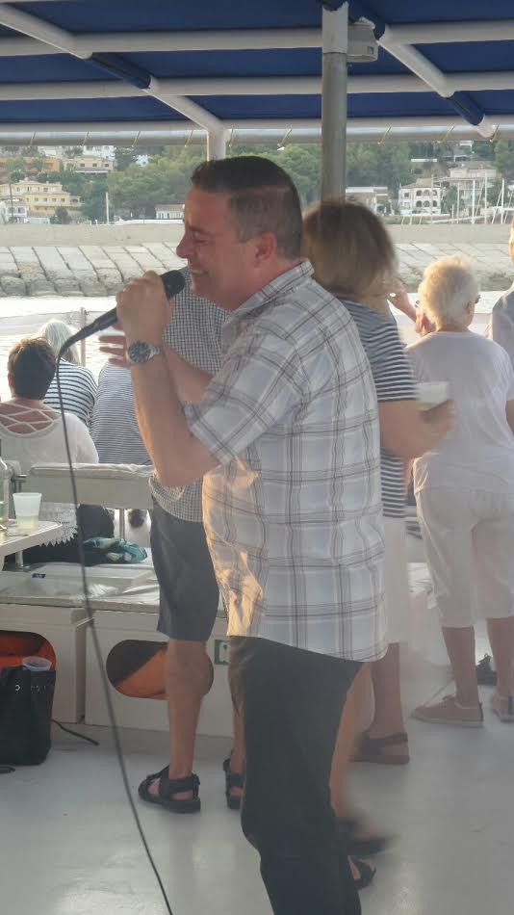

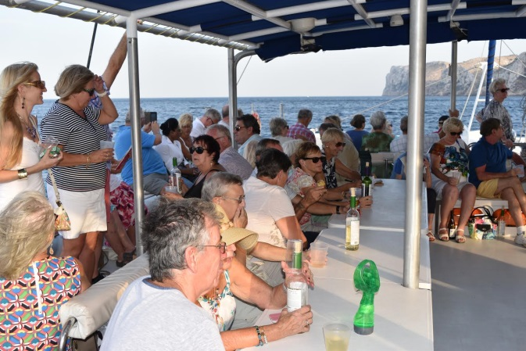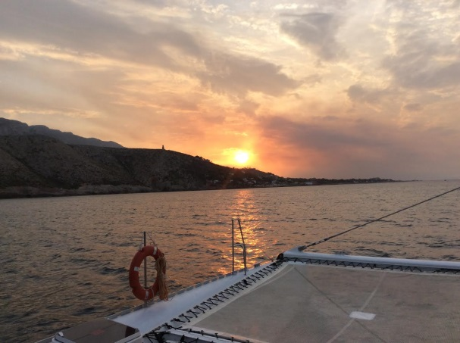

Some photographs of the event last year

There are just 12 places left now for this fundraising event on Sunday 11th June. Just €30 per person which includes goody food bag, ½ bottle of wine per person and entertainment by Rob Sweeney. A donation from each booking goes to raise money towards the summer outing to Aqualandia for the children who are resident at the care home in Dénia.

Please let me know now if you wish to reserve places for this event – travel@u3adenia.com

Aqualandia:

This is a special one day trip to Aqualandia by coach from Dénia as a summer treat for the children who are resident at the care home in Dénia which is funded by the generosity of U3A Dénia members who contribute with donations in the ‘pink bucket’ at the monthly members meetings and also attend the fund raising events which we hold during the year.

Aqualandia have given us a special entrance price for the 23 children and their carers. They have also offered a special price of €24 per person for any of our members who would like to attend. So if you have visitors at that time, especially younger family members, and you would like to treat them to a special day out, (€18 per child) then please let us know. You will be very welcome and the staff at the home have stated that they would love to meet some of the members who support them. It is also an opportunity to meet the children. As you can appreciate the home were understandably reluctant initially to have any details of the children released – and they still insist that no photographs of these vulnerable children are publicised outside of the U3A - which we fully understand and comply with.

Any U3A Dénia members and guests who wish to join the children for this event are very welcome and on arrival at the park can enjoy the day doing their own ‘thing’. They will not be asked to pay anything towards the coach – just the special entrance fee. Just let me know as soon as possible if you wish to take advantage of this offer – contact travel@u3adenia.com and let me know how many adults and children you wish to reserve places for. The coach will be collecting from the main bus stop on the front in Dénia – at the bottom of the Marquis de campo.

St Josep Caves, Val D’Uixo – 22nd June

Thursday, 22 June. Cost: €50 pp including 3 course lunch with wine/water

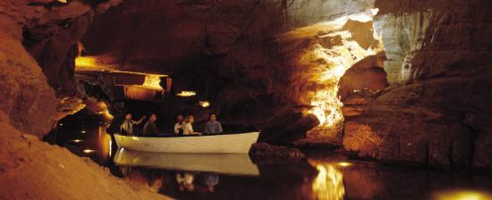

The Sant Josep Caves are situated in the Sierra de Espadán Nature Reserve in the Vall d'Uixó, between Sagunto and Castellón. The longest navigable underground river in Europe flows through the caves, where archaeological remains of Palaeolithic sites and cave paintings have been found. During our English-guided 40 minute visit by boat and on foot, we'll see drawings from people who lived there over 15,000 years ago, dinosaur caves and impressive illuminated stalactites and stalagmites. The caves are an amazing natural phenomenon and are extraordinarily beautiful.

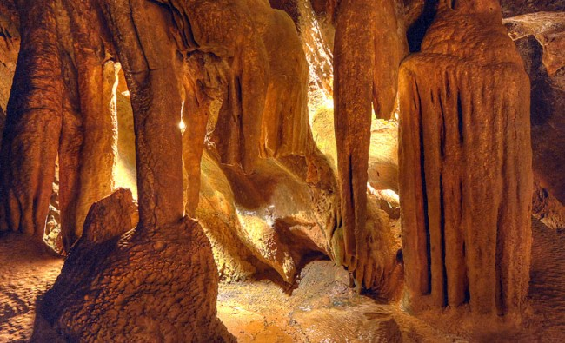

Following the trip, we take the coach to the nearby El Guano Bodega Restaurant, which is highly rated by Tripadvisor, for a delicious three course meal with wine.

This is a superb opportunity to visit these caves and enjoy lunch in a beautiful setting.

This trip is going ahead but there are just a few places left

Contact: pamrowlinson@gmail.com

